

As we get into the heart of summer, I hope you are enjoying, or planning, something fun for yourself, and maybe with those you love. (I’m free!) It seems the research on happiness that I’ve been reading routinely emphasizes the lift from meaningful **experiences** far exceeds material possessions or a larger portfolio. Maybe go somewhere cooler—it has been so hot. In my opinion, the ***worst time to have a fun experience is “later***”.  I know it is not easy to spend money after a lifetime saving it. The traits that make you a good saver can work against you becoming a spender. This is a difficult “re-wire” for many. I understand the reluctance to spend, a reluctance often rooted in a powerful fear of running out of money. There is also the risk of dying before you put your savings to good, fun, meaningful use. Yes, finding a comfortable balance between future security and living life to the fullest can be challenging. *Let’s figure out that balance together!*

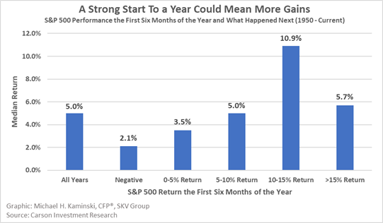

The first half of 2024 has been the 21st best since 1900 for the stock market according to Goldman Sachs research. Also, there has not been a correction of 5% or more since the low in October of 2023-no doubt frustrating market timers waiting for a good chance to get back in. A strong first half of the year usually bodes well for the second half of the year. Meanwhile, the Dow Jones Index created in 1896 has risen 68% of the time in the second half of the year. Given the stock market rises about 2/3rds of the time in general, it really is the markets upward bias overall reflected in these statics rather than anything unique about a particular time of year. All of history suggests the market could relentlessly march higher over time, while being routinely interrupted with sometimes steep, but so far always temporary declines.

Heads up, next Tuesday, July 23rd, is National Gorgeous Grandmother Day.  Alice Solomon created this holiday in 1984 to honor women “of a certain age,” grandmothers or not. By the way “of a certain age” is not specific other than no longer young. Tread carefully here. This alert gives you time to plan something (see #1 on this email). Worst time to plan for Gorgeous Grandma Day, is “later”.  You should know we have many gorgeous grandmother readers—so they too have been alerted and will have expectations…

*God, grant me the serenity to accept the things I cannot change, the courage to change the things I can, and the wisdom to know the difference. —Reinhold Niebuhr.*



The opinions expressed in this report are those of the author(s) and are not necessarily those of Wells Fargo Advisors Financial Network or its affiliates. The material has been prepared or is distributed solely for information purposes and is not a solicitation or an offer to buy any security or instrument or to participate in any trading strategy.  S&P 500 Index: The S&P 500 Index consists of 500 stocks chosen for market size, liquidity, and industry group representation. It is a market value weighted index with each stock's weight in the Index proportionate to its market value. Past performance is no guarantee of future results. Wells Fargo Advisors Financial Network is not a legal or tax advisor. Be sure to consult your own tax advisor and investment professional before taking any action that may involve tax consequences. Index returns are not fund returns.  An index is unmanaged and not available for direct investment. Past performance is no guarantee of future results. Asset allocation and diversification are investment methods used to help manage risk.  They do not guarantee investment returns or eliminate risk of loss including in a declining market.

**Michael H. Kaminski**, CFP®

*President*

SKV Group, LLC

1405 Rolkin Court, Suite 202

Charlottesville, Va 22911

FAITH. DISCIPLINE. PATIENCE

Ph 434.328.8040

[www.skvgrp.net](http://www.skvgrp.net/)

